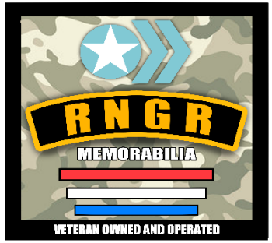
RNGR Mem Send in Form
Senders Name/Signers name
2006 Abrams Court
Murfreesboro, TN 37130
Email orders to: rngrmem@yahoo.com

Customer Name: _____________________ Customer Email:___________________________
Customer Address: _____________________________________ Phone #:___________________

Celebrity NAME | Amount and Item being signed (Be specific) | Price | Total of JSA @ $10 Per (Y/N) | Total

***Please properly label each item with your name, pen color and, inscription if requested. Also if there is a preferred location you would like the autograph. Please be Specific***
**Return shipping you will pay Exact amount calculated and charged after signing. Return labels preferred. If insurance is requested on return shipping, please indicate that on this form**

Payment Options: We accept Check, Money order, Venmo, Cashapp. If wanting to use PayPal goods, please add 4% to the total.
PayPal : rngrbrown@yahoo.com @SBrown844 Venmo : @rngrmemorabilia

RNGR MEMORABILIA THANKS YOU IN ADVANCE FOR YOUR ORDER!

